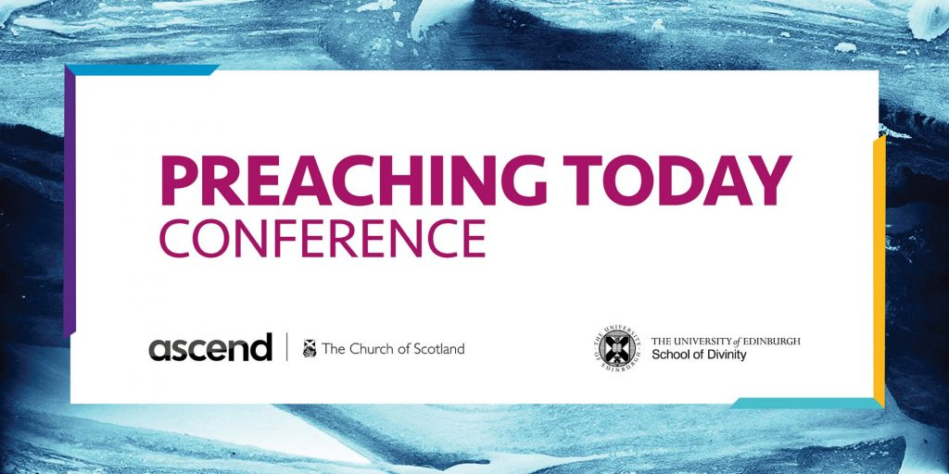

Preaching Today – the third conference on this theme hosted by Ascend and New College, University of Edinburgh – will take place on Monday 19 April, 11:00-16:00, online. The event is free, but please register here to receive the weblink that will be emailed out a few days beforehand.

Please join us for a day of thought-provoking talks and small group conversations: time to reflect together on what it means to preach today.

Preaching Promise in a Time of Lament
Revd Canon Dr Rachel Mann: preacher, poet, writer, philosopher, Rector of St Nicholas, Burnage, Manchester

Too Close for Comfort? Preaching by Video
Revd Neil Glover of Aberfeldy Parish Church & Revd Dr Marjory MacLean of South Ronaldsay + Burray Parish Church and Development Officer, Presbytery of Orkney

A Glint, a Dewy Wisp, a Mote – Preaching and Poetry
The Very Revd Dr Russell Barr: Moderator of the General Assembly of the Church of Scotland in 2016, former minister of Cramond Kirk, Edinburgh

Repairers of the Breach: Preaching in the Post-Pandemic Church
Revd Professor Sally A. Brown: Elizabeth M. Engle Professor of Preaching and Worship, Princeton Theological Seminary
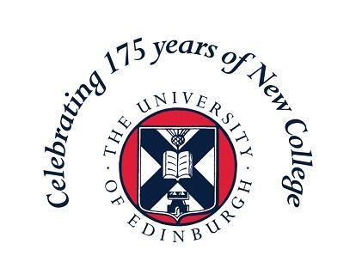

For New College, this conference is part of a programme of events across 2021 to mark our 175th Anniversary:
https://www.ed.ac.uk/divinity/news-events/new-college-175/programme

