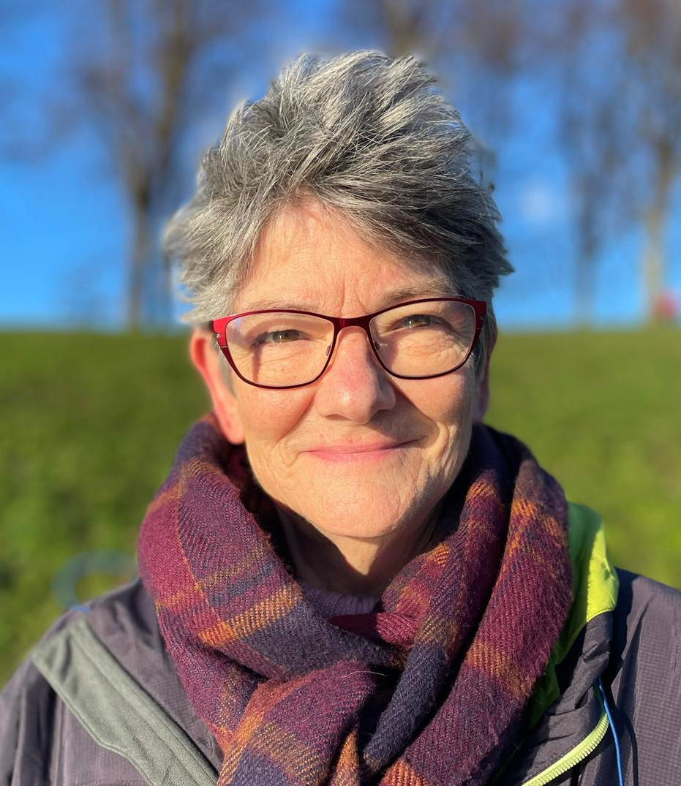

Susan Scarth

EDINBURGH CITY

Susan has been supervising students and experienced practitioners for many years, bringing a creative focus to the work. She runs a Movement Psychotherapy practice in Leith, Edinburgh where her clients are mainly adults dealing with traumatic histories. Her supervision practice supports ministers, nurses, arts therapists and psychotherapists. Susan completed Michael Paterson’s Reflective Practice and Creative Supervision diploma to consolidate skills learned ‘along-the-way’. Her background is in social work, community development and mental health services in NHS and voluntary sector, and later in higher education as lecturer/course leader in London and Edinburgh.
Website: movementpsychotherapy.org
Tel: 07962814630
Email: susan@movementpsychotherapy.org

